* Screenshot of the environment variables

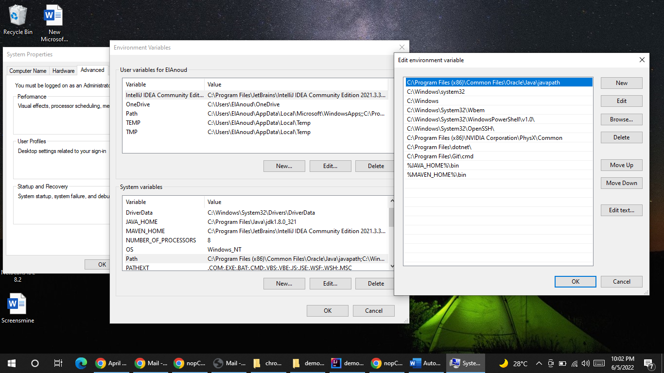

* Screenshot of the external libraries in the Maven project

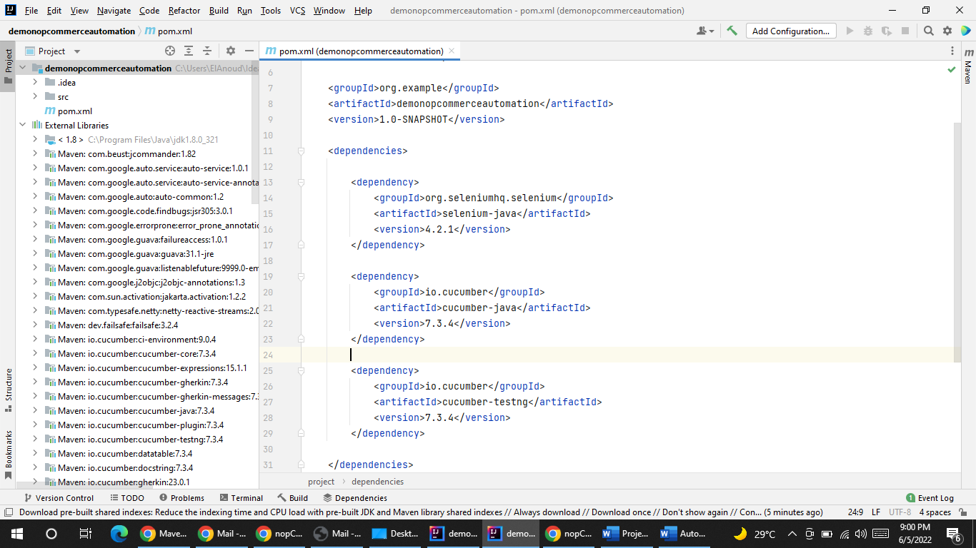

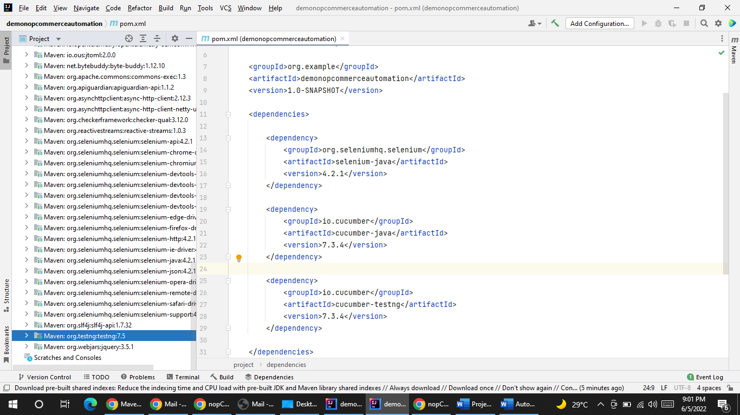

* Screenshot of the Maven project settings

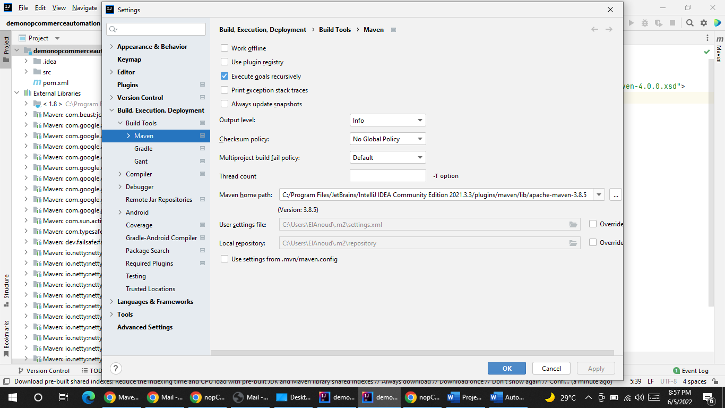

* Screenshot of the selected Maven stable version from the Maven website

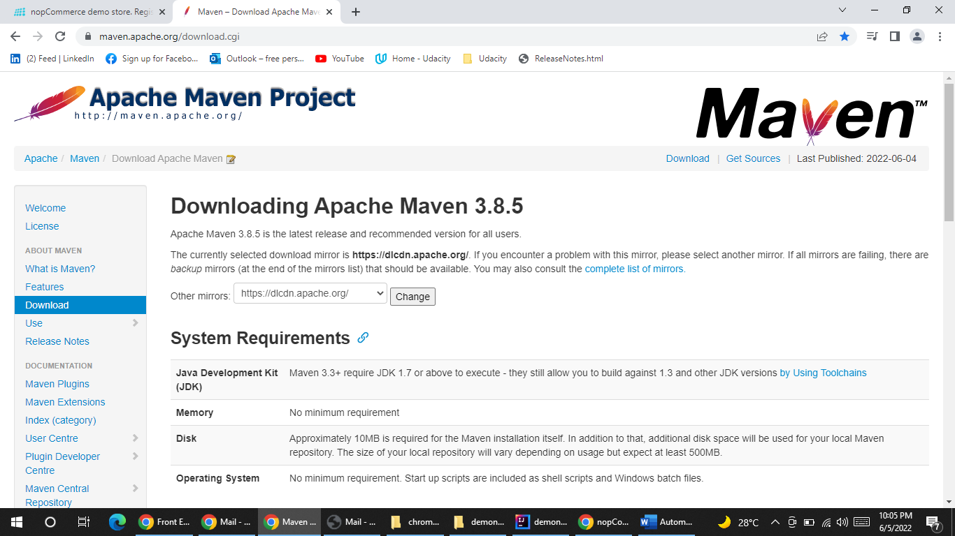

* Screenshot(s) of Maven repository/website showing the selected & used versions of automation, assertion, and behavioral-driven frameworks

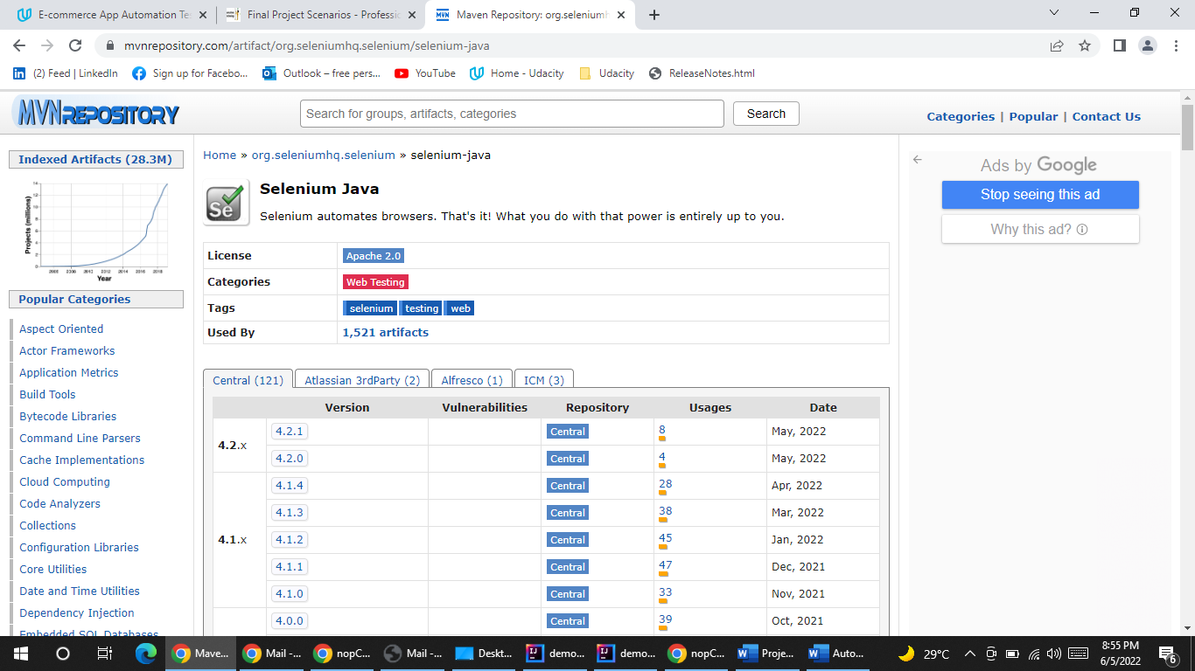

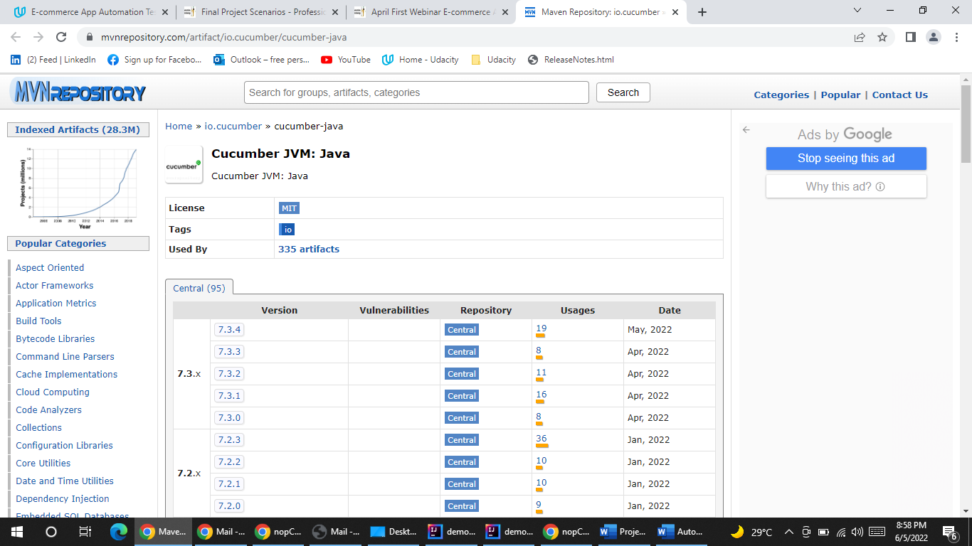

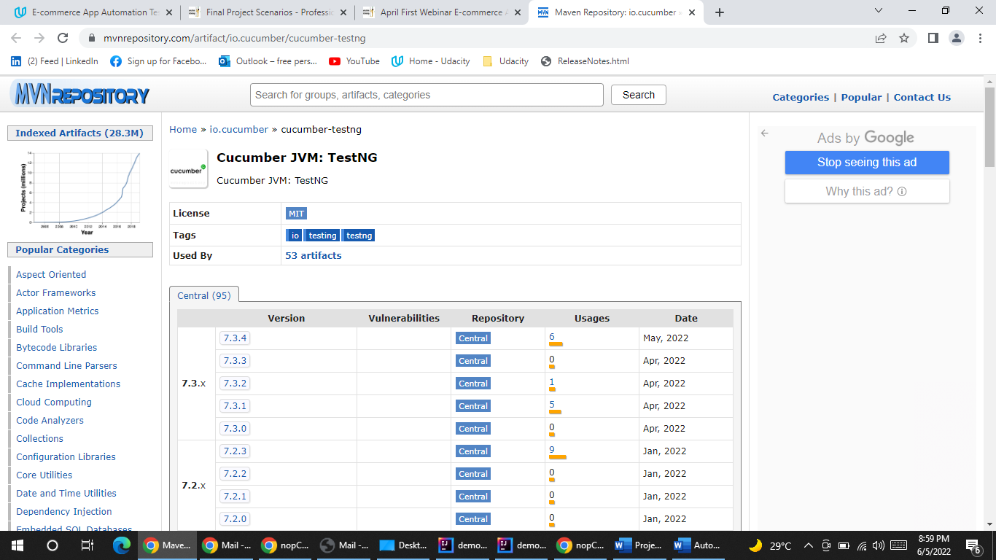

* Screenshot for IntelliJ plugins showing required Plugins installed

